Tab bar

Workshop #04

Flutter Developer Bootcamp

# **Purpose**

This workshop demonstrates how to create a tab bar to list several screens.

# **Problem**

In the workshop provided, you aim to create a search icon and a profile icon within the tab. When the user taps on the search icon, it will display the search screen, and when the user taps on the profile icon, it will show the profile screen. Additionally, the tab bar should include text below the icons corresponding to their functions.

# **How to Solve**

1. Checkout the workshop from Git Repo:

git clone -b <user-branch> <repo-URL>

2. Open the root folder inside VS Code

3. To build the app click the run option in the main method { }

4. Create two tabs: 'Search' and 'Profile'.

# **You Will Achieve**

At the completion of the workshop, you'll learn how to create a home screen with a tab bar in Flutter. This includes implementing tabs for "Home", "Search", and "Profile", customising the AppBar with an orange background and centred title, and displaying text with increased font size for each tab. This hands-on experience will give you a solid understanding of tab bar layouts in Flutter.

# **Screenshots**

## **Before implementation (without Search screen & Profile screen )**

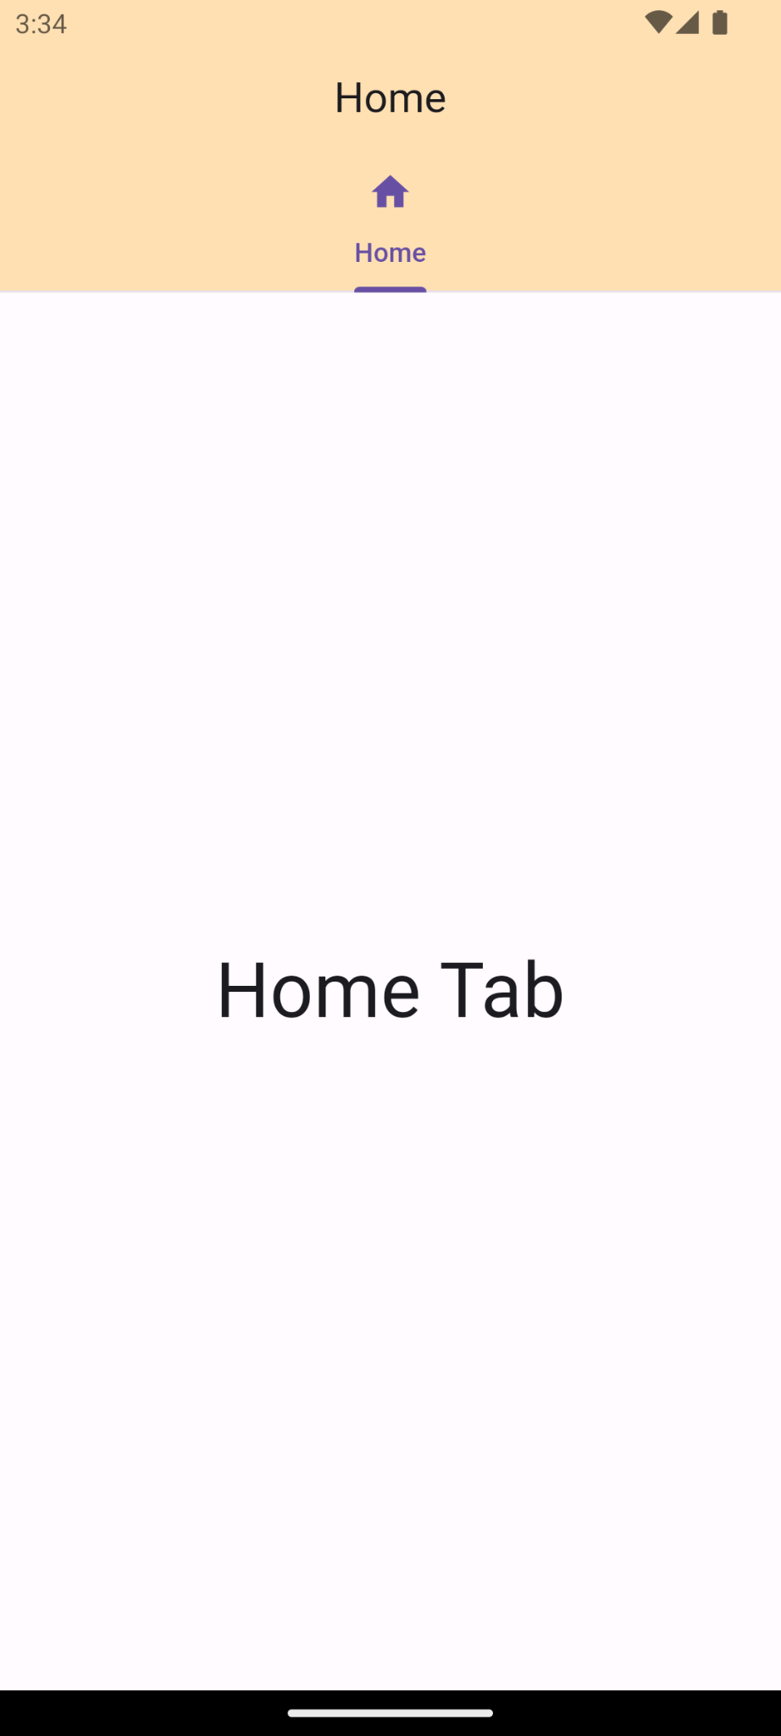

## **After implementation (With screen & Profile screen)**

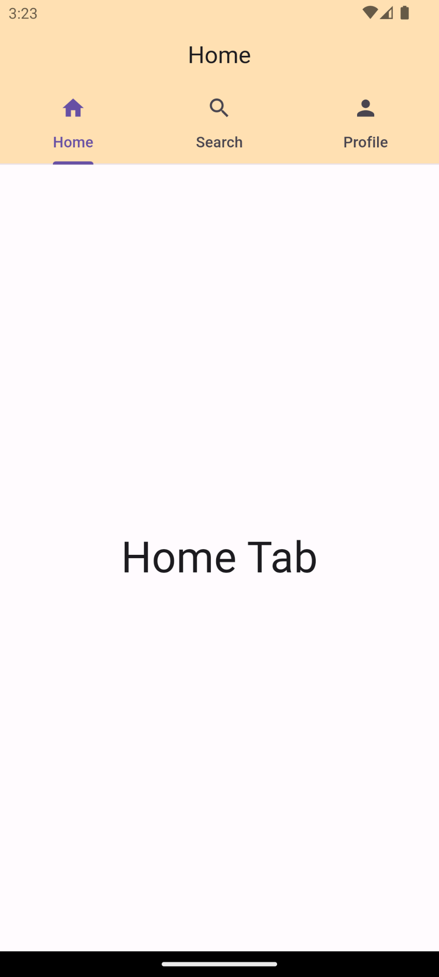 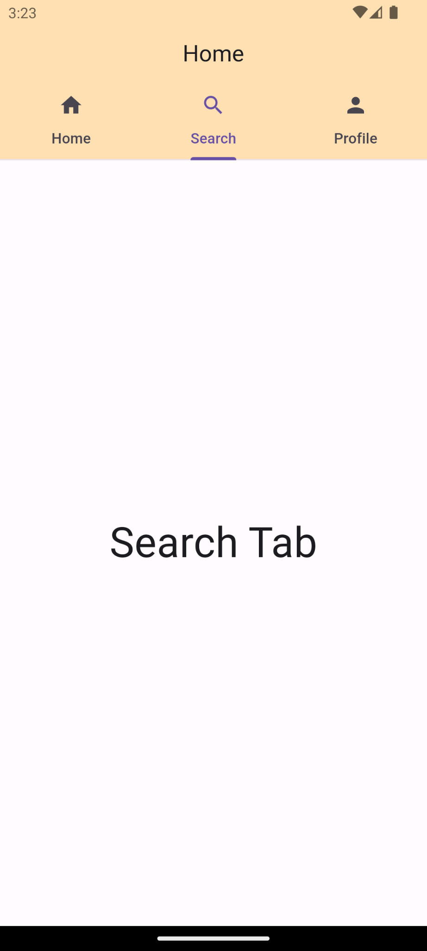 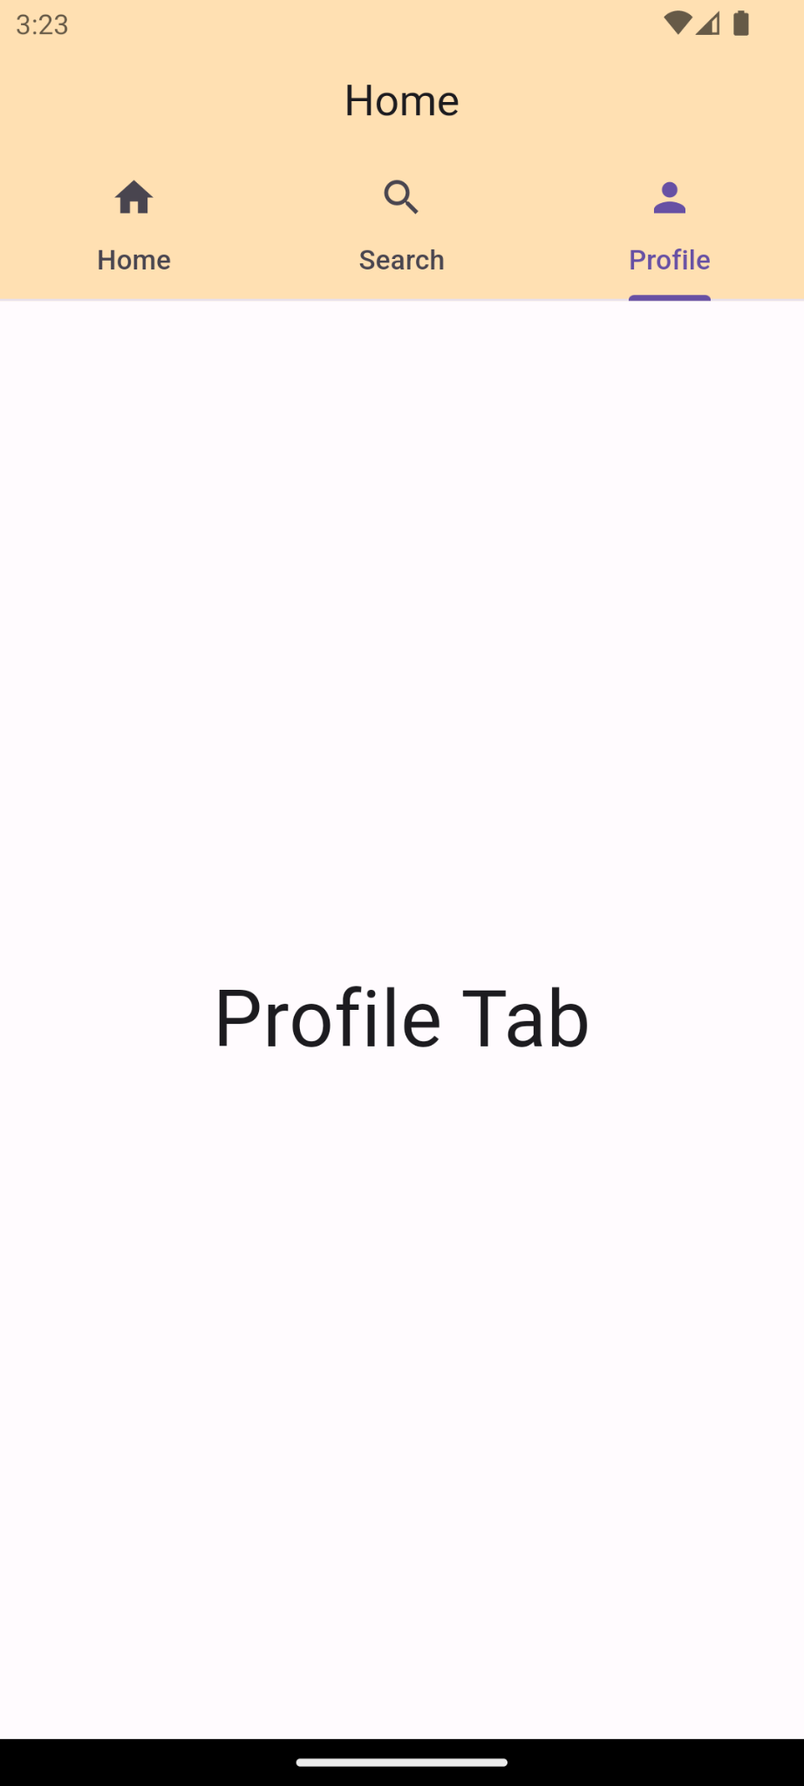

# **How to submit your workshop**

Push your project back to the same git branch using command:

<command name>

# **Happy Coding!**